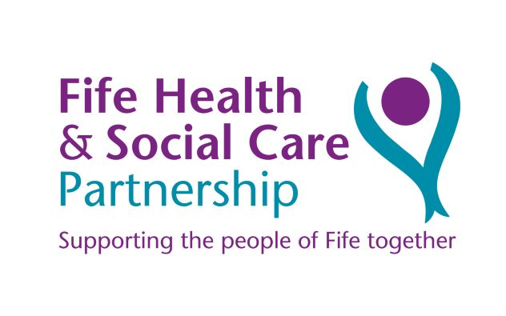
Fife PPE Request Form – Lateral Flow Testing Kits
Complete and attach this form to your email and return to Fife.PPEHub@fife.gov.uk
You will be able to pick up the LFT kits within 24hrs of sending the order via email
Date form submitted (e.g.11.01.21)

Name of person ordering Lateral Flow Testing Kits:

Name of Service:

Address:

Postcode:

Preferred Contact Number:

SSSC registration number

Number of lateral flow testing kits required:
(one box contains 25 kits)

PLEASE ENSURE YOU COMPLETE THE FORM IN FULLTO ENABLE YOUR ORDER TO BE PROCESSED
Note: All staff are required to watch the video and read the guidance before undertaking the lateral flow test. This will be provided by your line manager.
Note: It is an individual’s workers responsibility to record the result of the test regardless of the results on the COVID-19 Testing Results Portal: www.covidtestingportal.scot

